COMSATS UNIVERSITY ISLAMABAD, ATTOCK

ASSIGNMENT #03

Name : Maaz Khan

Reg No: CIIT/FA17-BSE-028/ATK

Program: BSE

Subject: Software Quality Engineering

Submitted to: Muhammad kamran

Date: 11-11-2019

**Software Requirements Specification of**

**COLLEGE MANAGEMENT SYSTEM**

**Table of Contents:**

**Chapter-1{intro and requirements gathering}**

**Abstract.**

**1-Introduction**

**1.1-purpose**

**1.2-E-R model.**

**2-Overall description**

**2.1-Scope:**

**2.2- Product perspective:**

**2.2.2-User interfaces:**

**2.2.3-Hardware interfaces:**

**2.2.4 Software Interfaces:**

**2.1.4-Memory constraints:**

**2.3-User charateristics:**

**2.4-Constraints:**

**3-Functional requirements:**

**Use case.**

**Activity diagram.**

**Class diagram**

**Sequence diagram.**

**3.1- LOGIN**

**4-Input Requirements:**

**4.1-User access:**

**4.2-Uploading data:**

**5-Other non functional requirements:**

**5.1-Performance requirements:**

**5.2-Safety requirements:**

**5.3-Security requirements**:

**5.4-Software quality attributes:**

**5.5-Hardware Constraints:**

**5.6-Software Constraints:**

**5.7-Design constraints:**

**Chapter-2{Design}**

**1-System design:**

**1.1- Purpose**

**1.2- Target audience.**

**1.3- Concepts.**

**1.4- Pre-requisites.**

**5.5-Architectural strategies:**

**5.5-Data flow diagrams:**

**Chapter-03**

**Implementation.**

-**CMS homepage.**

**-About CMS.**

**-Infrastructure.**

**-Student admission form.**

_________________________________________________-

**Chapter-01**

Abstract:

* This paper is aimed at developing an Online Intranet College Management System (CMS) that is of importance to either an educational institution or a college.
* The system (CMS) is an Intranet based application that can be accessed throughout the institution or a specified department. This system may be used for monitoring attendence for the college.
* Students as well as staffs logging in may also access or can be search any of the information regarding college.
* Attendance of the staff and students as well as marks of the students will be updated by staff.
* This system (C.M.S ) is being developed for an engineering college to maintain and facilitate easy access to information. For this the users must be registered with the system after which they can access as well as modify data as per the permissions given to them.
* CMS is an intranet based application that aims at providing information to all the levels of management with in an organization.
* This system can be used as a knowledge/information management system for the college.
* For a given student/staff (technical/Non-technical) can access the system to either upload or download some information from the database.

**1-Introduction:**

* The project is aimed at developing online application for the college.
* The system is an online application that can be accessed throughout the organization and that will full fill all the needs of the organization.
* This project can be used as an application for the college to manage the student information and college managing.
* The college management and staff logging should be able to upload their information in the form of a CV, student record and college department record.
* College staff representatives may also search or access any information entered by students

**1.1-Purpose of the project:**

* This project will be mainly used for College system to keep the record of new or old students and college staff.
* It will use many operation for keeping the record. We use student registration and college department record stored and performs for the HOD of the department form, search form and College department and students records.
* The main purpose of this project to keep the record of the whole college which may include students, staffs, accounts section etc.

The main purpose of the college management system project are the following:

1. Easy searching of student, college and employee information.
2. Decrease overheads.
3. Minimization redundancy.
4. Make data more secure.
5. Improve report generation process to improve decision making.
6. To provide fast accurate and consist response.
7. proposed system according to the current demand.

1.2-E-R model:

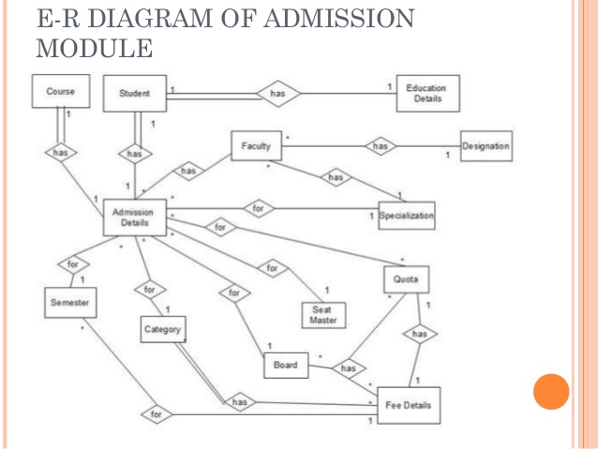

**2-Overall description:**

* The college management system allows authorized members to access the records of registered students.
* It can be used in various educational institutes across the globe simply in all institutions.

**2.1-Scope:**

* The project has a large scope. We can store information of all the student and college record.
* Various companies can access the information and can update it.
* Notifications are sent to students about the companies. Students and college department can access previous information about college.

There are following modules and forms are used-

1. Institute record.
2. Student record.
3. College management system.
4. Category’s selection form.
5. Reporting withdraw.
6. Campus placement.
7. Staff salary.
8. New admission.
9. College results.

**2.2- Product perspective:**

* The system will be developed using client/server architecture and be compatible with Microsoft windows operating system.
* The front end of the project will be developed using visual basic software and the backhand will be developed using SQL server.

**2.2.2-User interfaces:**

The college management system will have the following interfaces.

* Login:

It allow the entry of authorized users through valid login id and password.

* College details:

it will use to maintain all the college details.

* Program details:

It will maintain all the details of all the programme.

* Faculty details:

It will maintain all the faculty detailes.

**2.2.3-Hardware interfaces:**

* Screen resolution of at least for example 640 by 480 or above.
* Support for printer.
* Computer system must be in the network environment.

**2.2.4 Software Interfaces:**

* MS windows operating system.
* Microsoft visual basic for designing front end.
* SQL server for backhand.
* Java language.

**2.1.4-Memory constraints:**

At least 1 GB of ram and 2 GB of space is needed to run the desired software.

**2.3-User charateristics:**

* **Qualification:** At least matriculation and comfortable with English.
* **Experience :** Experienced should be well informed about the registration

process of the college.

* **Technical Experience:** must have the knowledge of computers.

**2.4-Constraints:**

* There will be only administrator.
* The delete option should only be available to the administrator.
* In order to reduce the complexity of the system.
* There is no check on delete operation.
* So the admin should be very careful before the deletion of any student record otherwise he will be responsible for data consistency.

**3-Functional requirements:**

**3.1- LOGIN**

**Use case description:**

**1-Introduction:**

This use case documents the steps that must be followed in oder to log in to the college management system.

2-Actors:

Administrator

Student

Faculty.

**3-Pre condition:**

The user must have valid login id and password.

**4-post condition:**

If the use case is unsuccessfull the actor is logged into the system.

If not the system remains unchanged.

**5-Basic flow:**

1. The basic flow starts when the actor wishes to login onto the college management system,
2. The system requests that the actor specify the function that he/she would like to perform.(login, change password).
3. Once the actor provides the requested information, one of the subflow is executed.

* If the actor selects login the login sub flow is executed.
* If the actor selects change password the change password sub flow is executed.

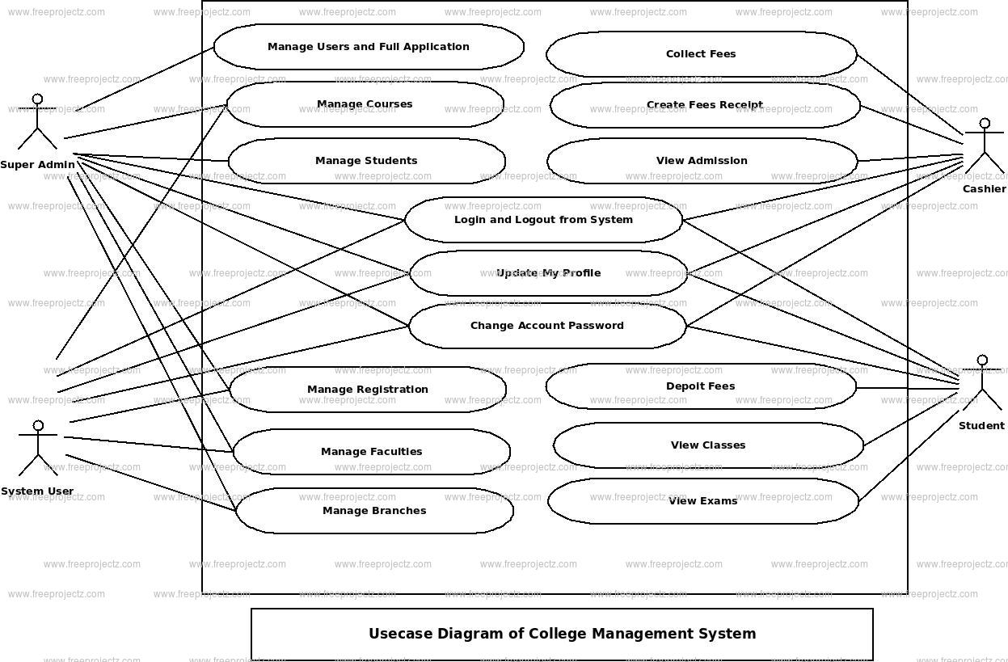

**Activity diagram:**

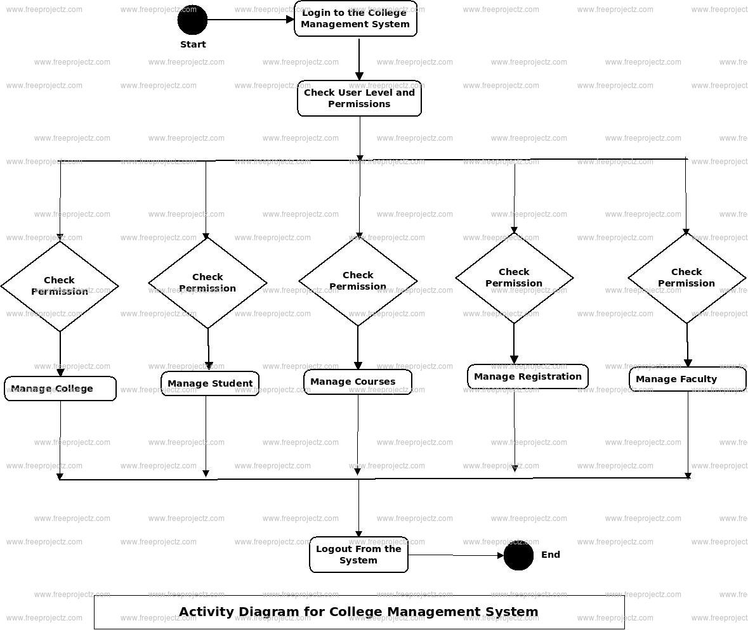

**Class diagram:**

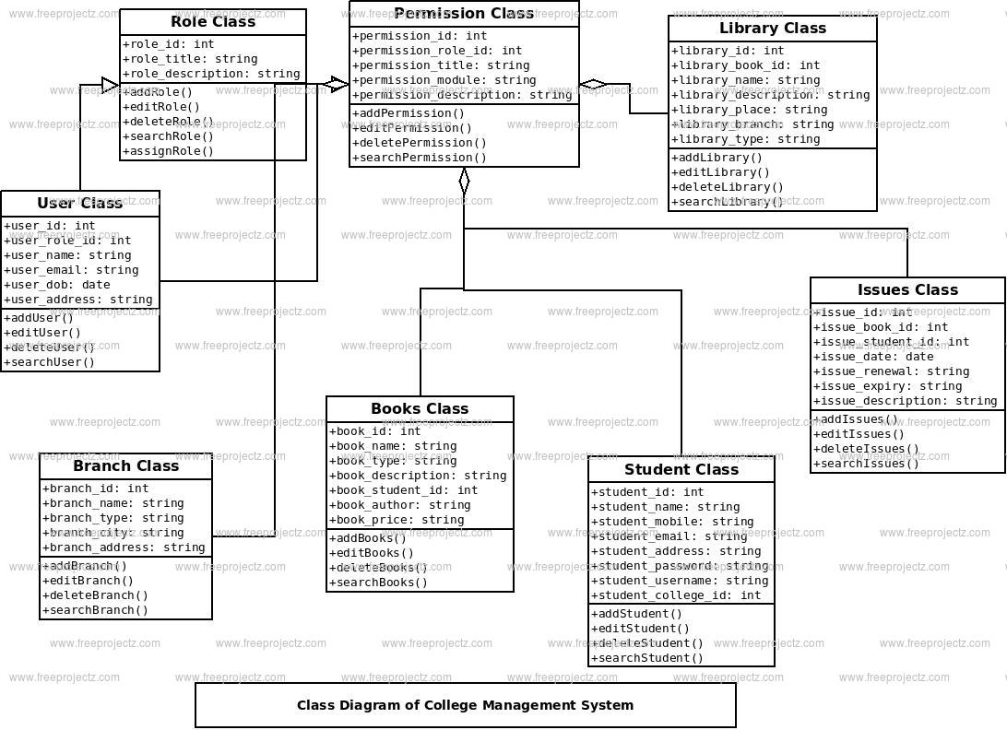

**Sequence diagram:**

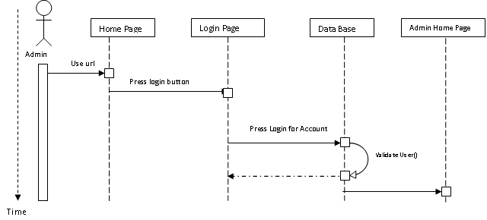

**4-Input Requirements:**

**4.1-User access:**

* Every employee and student is appointed a one of a kind of identification upon admission to the college.
* This two must know this.
* This recognizing key maps to all his/her enlistment record information in the primary enrollment framework.
* Admitted and current understudies student have their online enlistment accounts also enabled.
* Such record perhaps disabled during his/her stay as as matriculated student and additionally after graduation or removing from the college.

**4.2-Uploading data:**

Every employee has the access to en courage with transferring of information, for example, assignments, their imprints and other sort of perusing material. So also such of choice must be available their for students to upload their assignments.

**5-Other non-functional requirements:**

**5.1-Performance requirements:**

* The proposed system that we are going to develop will be used as the Chief performance system within the different campuses of the college which interact with the college staff and students.
* Therefore, it is expected that the database would perform functionally all the requirements that are specified by the college.

**5.2-Safety requirements:**

* The database may get crashed at any certain time due to virus or operating system failure. Therefore, it is required to take the database backup.

**5.3-Security requirements**:

* We are going to develop a secured database for the college. There are different categories of users given below:
* Administrator, Staff members And students etc.
* Depending upon the category of user and the access rights are decided.
* It means if the user is an administrator then he can be able to modify the data, delete etc.
* All other users other than college Staff only have the rights to retrieve the information about database.

**5.4-Software quality attributes:**

The Quality of the database is maintained in such a way so that it can be very user friendly to all the users of the database

**5.5-Hardware Constraints:**

The system requires a database in order to store persistent data. The database should have backup capabilities..

**5.6-Software Constraints:**

* The development of the system will be constrained by the availability of required software such as web servers, database and development tools.
* The availability of these tools will be governed by the College.

**5.7-Design constraints:**

* The system must be designed to allow web usability.
* That is the system must be designed in a way that will be easy to use and visible on most of the browsers.

**Chapter-02**

**1-System design.**

**1.1-Purpose:**

* Purpose of College Management System for a College (CMS) Design Document is to explain the design and the architecture of CMS.
* The design is expressed in sufficient detail that allows you to allow all the developers to recognize the underlying architecture of CMS.
* Logical structure of JDBC driver, Server, DML, DDL, Session and Data Store are explained.

**1.2-Target audience:**

* This Design file is supposed to act as a technical reference tool for builders involved within the improvement of College Management System (CMS).
* This report assumes which you have sufficient knowledge of the subsequent

**1.3-Concepts:**

* RDBMS and its diverse factor modules.
* SQL.
* Java and JDBC.
* Interaction Diagrams.
* Classes and Interfaces.

**1.4-Pre requisites:**

* CMS calls for Java JRE 1.5 or better. Since CMS is written in Java, it can run on any platform that supports the Java runtime environment 1.Five or better.
* The compiled documents are contained in Java Archives (JAR’s) and must be defined inside the CLASSPATH environment variable.

**Top level Interaction diagram:**

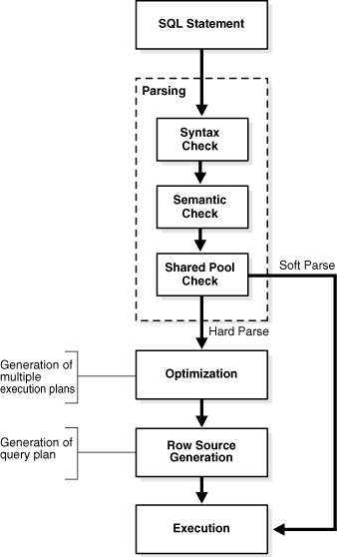

**2-Architectural strategies:**

* The architectural layout of a software mission is virtually the design of the complete software program gadget.
* This includes the hierarchy of the modules and additionally which modules are present inside the gadget.
* A properly architectural layout will create a clear and honest stability among concord (every module has handiest one awesome motive), coupling (no two modules rely absolutely on every other), abstraction (seeing modules in complete and no longer in element), hierarchy (logical modules stem from others) and partitioning (logically grouping modules collectively) of the software program modules

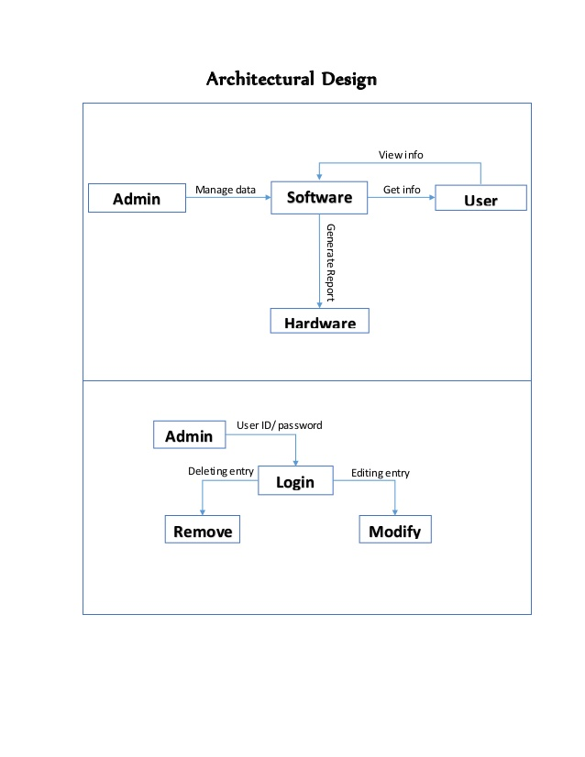

**3-Data flow diagrams:**

* The complete architectural structure stems from the original go with the flow design. Below are the Level zero, Level 1, Level 2 and Level3 Data Flow Diagrams (DFD).
* The diagrams below more as it should be painting the facts float through our gadget. These diagrams take precedence over the diagrams within the necessities document.

**Level-0 DFD diagram**

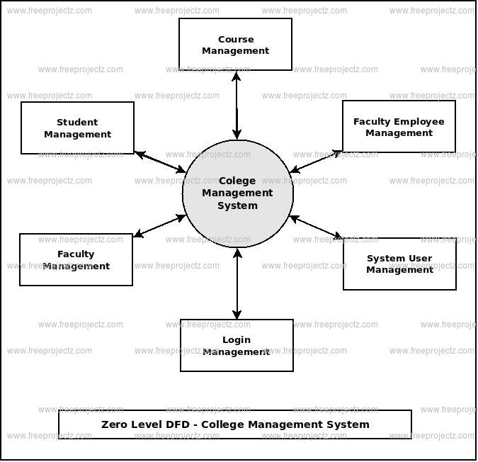

**Level-1 DFD diagram:**

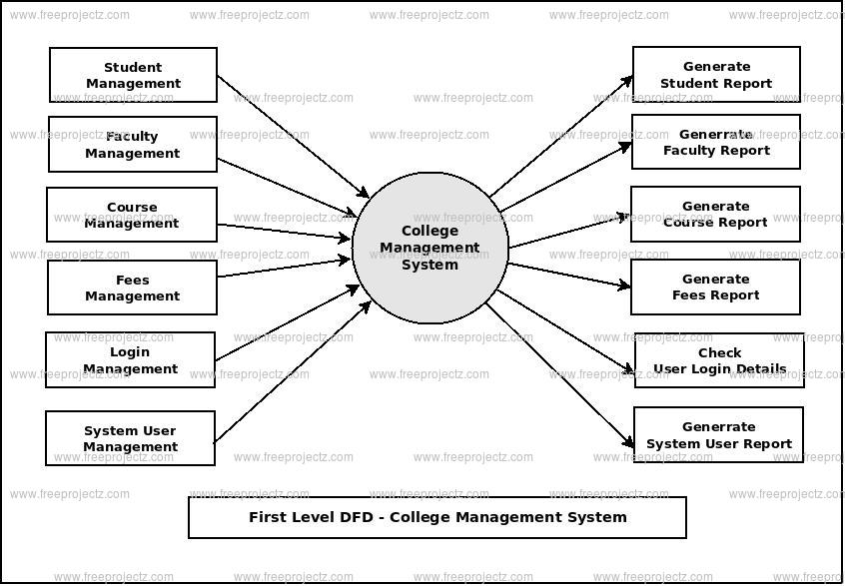

**Level-2 DFD diagram:**

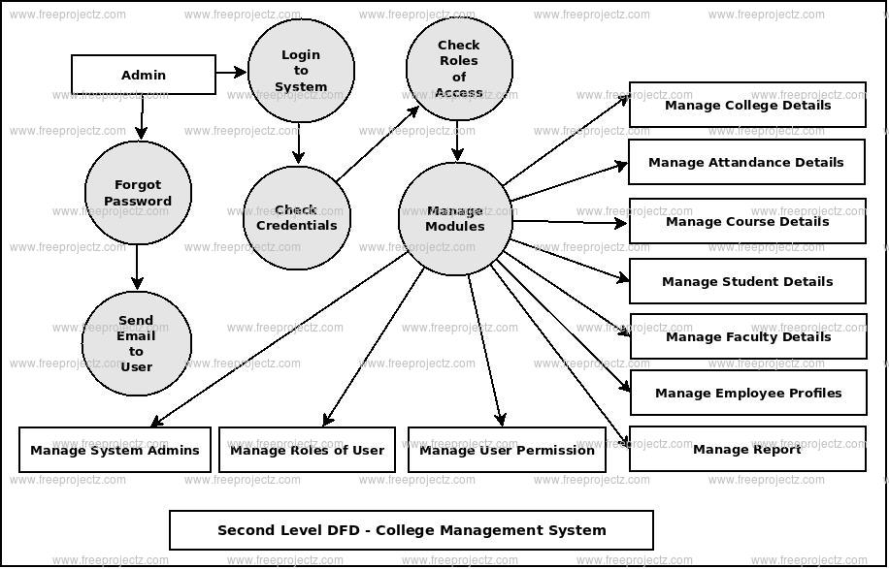

**Chapter -03**

**Implementation:**

**CMS home page:**

This is the home page for college management system. This page also contains the discussion forum topics. Here teaching/nonteaching staff or student can login by their id & password.

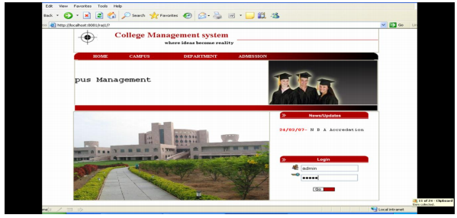

**About CMS:**

This screen gives the overview of the Knowledge Management System i.e., the main modules in KMS.

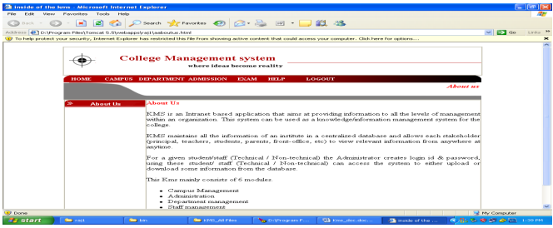

**Login:**

This screen tells about the security of the project so that an unauthorized user doesn’t access it and only the authorized user can have access to the system.

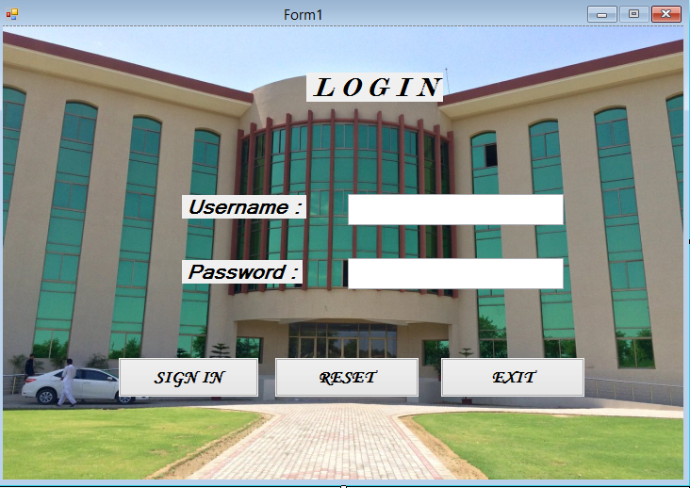

**Main menu:**

This screen will provide the guideline which tells who actually you are if student can access student data if admin can have access to admin data and if teacher can have access to teacher data

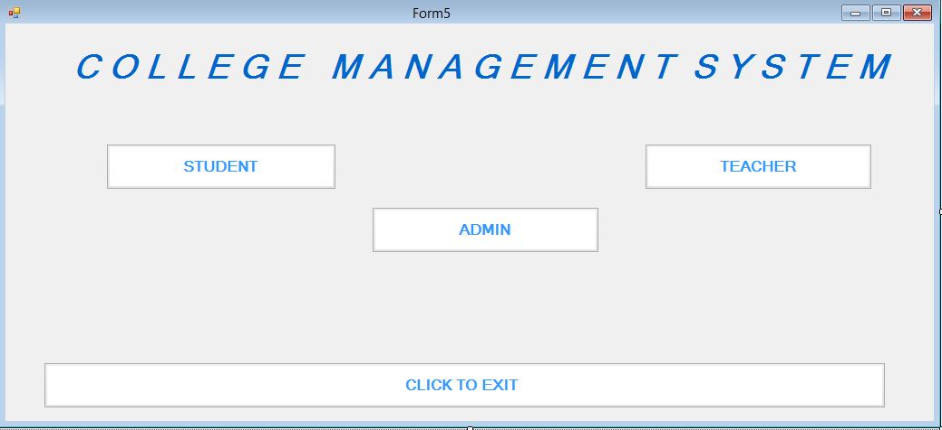

**Student:**

If the user is a student then he will be asked to enter his/her registration no and password in order to have access to the system.

The student information will be look like,

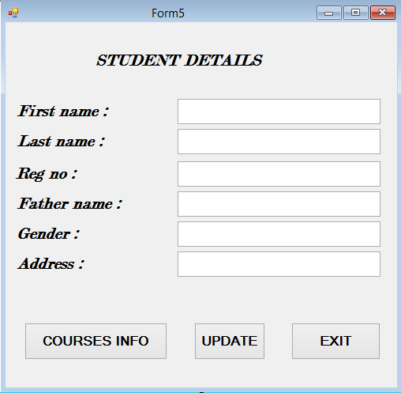

**Teacher:**

* If the user is teacher then he/she will be asked to enter his id number and password in order to have access to the console.
* In his console he will be able to see his/ her information or details and also he can manage the students by giving marks etc.

**Admin:**

* If the user is admin and control all the situations of college then he/she will also be asked to enter his/her identification in order to have access to his/her console.
* The admin can add student, can delete, student can update student.
* Similarly the admin can add teacher, can delete teacher and can update teacher.
* The admin can also handle other works of the college. The accounts matter are handle by the accounts section.

***REFERENCES:***

[1] D B Heras, D. Otero,and F. Arguello,” An eco feedback

system for impro ving the sustainability Performanceof

universities,” in Proc. 2011 IEEE International

Conference on Virtual Environments Human –Computer

Interfaces and Measurement Systems, Ottawa, ON 2011

, pp. 1 – 6

[2] Y Wang, B Y Sun, and F Cheng,“Electronic document –

based process model for image archives in niversities,”

in Proc. 2011 IInternational Conference on Information

Technology, Computer Engineering, and Management

Sciences , Nanjing, Jiangsu , pp. 57– 60

[3] X. X. Xin, R. M.Wu,and H. H.Li,“A faremework model

of the e-campus management system based on SOA,” in

Proc.2009 International Conference on Computational

Intelligence and Software Engineering Wuhan, 2009, pp.

1-3[4] H. M. Weiand L. J.He, “Constructing the

comprehensive academic affairs management system

based on SOA,” in Proc. 2009 1stInternational

Conference on Information Science and Engineering,

Nanjing, Jiangsu, pp. 3261-3264

[4] S. Jeyalatha, B. Vijayakumar,and G.S. Wadhwa, “Design

and implementation of web based application for

relational data maintenance in an university

environment,” in Proc. 2011 International Conference

and Workshop on Current Trends in Information

Technology , Dubai,pp. 105-112

[5] M-H.Lee, C -J.Yooand O.-B.Jang,“Embedded System

Software Testing Using Mobile Service Based On SOA”,

IJAST,vol. 1, (2008), pp. 55-64

[6] S.H. Al-Daajeh, R.E Al- Qutaish and Fuad Al-Qirem,

“Engineering Dependability to Embedded Systems

Software via Tactics”, IJSEIA, vol. 5,no.4,(2011),pp. 45-

62

[7] Ming-Syan Chen, Jiawei Han, Philip S yu. Data Mining:

An Overview from a Database Perspective[J]. IEEE

Transactions on Knowledge and Data Engineering, l996,

8(6):866-883.

[8] R Agrawal ,T 1 mielinski, A Swami. Database Mining: A

Performance Perspective[J]· IEEE Transactions on

Knowledge and Data Engineering, 1993,12:914-925.

[9] Vasant Dhat. Data Mining In Finance: Using

Counterfactuals to generate knowledge from

organizational information

[10] System[J].Information System,1998,23(7):423-437.

[11] Rakesh Agrawal, Sakti Ghosh, Tomasz Imielinski, Bala

lyer, Aran Swami. An Interval Classifier for Database

Mining Applications[M]. CLDB92. Vancouver, British

Coumbia, Vanada, 1992:560～573.

[12] J Han, Y Cai, N Cercone. Knowledge Discovery in

Database: An Attribute-Oriented Approach [M]. VLDB92, Vancouver, British Columbia,Canada,1992:547-559.

[13] J.Hipp, U.Guntzer, G.Nakhaeizadeh. Algorithms for

-----------------------------------------------------------